NAME: Ondřej Marvan 477001
This lecture report will focus on the subjective evaluation of the model inserting taxes on the perfectly competitive market and the influence of taxes on demand for labour, profits and production on a typical firm. You will have instant visualization of many functions. Based on them, you should assess their external validity. Remember that the numbers (p, w) are artificial and do not interpret them – it is a problem of calibration of the function. You have to focus on the behaviour of the functions and interpret their behaviour.
In your exam, in some tasks, the input is personalised by N1, N2, N3, N4, N5 the sequence of the first 5 digits from your student ID. Today we use only N1 and N5. But it will be enough to create many versions of the task. Only input it into the task and run the code. [sometimes to improve the quality of the graph you should change the graph option – intervals of drawing which are bolded in code].
Problem:
The production function of a typical company producing boxes of candies can be approximated by the formula Y(L)=500*(N1+N5 + 20)L^(0.5). The company operated in perfectly competitive conditions. The price of the box of candies is given p = (N1+N5 + 5). The market wages in this sector are w = 5100. How will the introduction of a tax on the firm (considered producing an unhealthy product) affect the demand for labour at a typical company? What will be the company’s production and profit levels? What is the optimal tax rate that maximizes tax revenue for the government? Furthermore, how will the optimal tax rate impact the company?

Answer:
When a tax is introduced in a perfectly competitive market, it raises the cost for firms to produce each unit. Since these firms can't raise prices above the market rate without losing sales, they end up bearing the extra costs. Typically, they aim to produce where their costs balance with their revenue (at market price), so the added tax pushes them to produce less to stay profitable.

With less production, they need fewer resources, including labor. In competitive labor markets, companies hire as long as the extra revenue from each worker matches the wage. With production down, the revenue per worker drops, so firms cut back on hiring, either by reducing hours or letting workers go.

a (t=0 => no tax)
kill(all);

assume(w > 0, L > 0, p > 0, t > 0);
/* Student ID 477001 */

N1: 4;
N5: 0;

w: 5100;
A: 500;
t: 0; /* per unit tax */

p: (N1 + N5 + 5);

/* enter the production function */
Y: A * (N1 + N5 + 20) * L^(0.5);

/* Profit = TR - TC */
/* TR = p * Y */
/* TC = w * L + t * Y */

/* enter the profit function */
Profit: (p * Y - w * L - t * Y)$

/* calculate f.o.c */
eq1: diff(Profit, L, 1) = 0;

float(solve(eq1, L));

L: rhs(%[1]);

/* outputs */
print("t = ", ''t) $
print("p = ", ''p) $
print("L* = ", ''L) $
print("Y* = ", ''Y) $
print("Π* = ", ''Profit) $
print("T* = t * Y* = ", ''t * ''Y) $
print("Cost of work = ", ''w * L) $
print("Revenue = ", ''p * ''Y) $

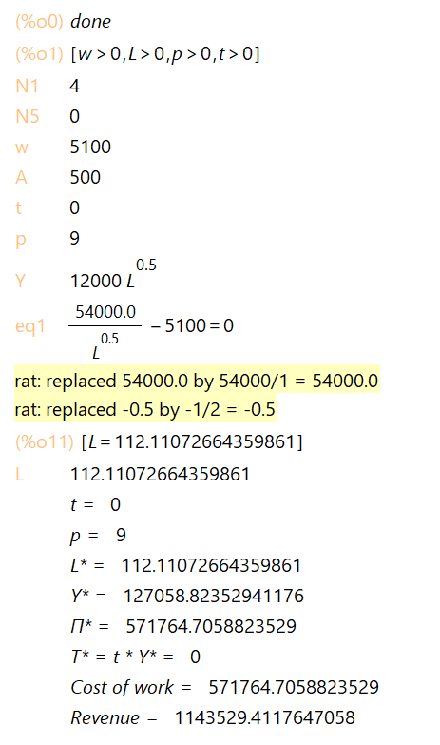

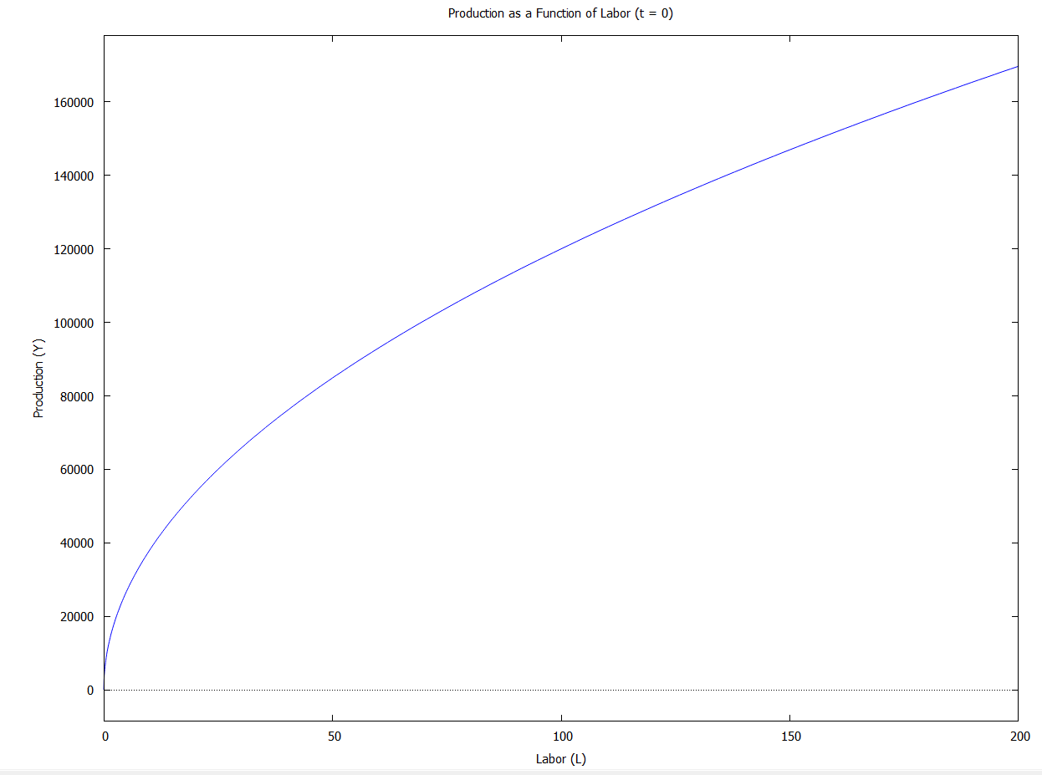
Analysis No Tax (t = 0):
In this section, the production and profit levels of a firm operating under perfectly competitive conditions, without any taxation imposed, are evaluated. Using the production function Y(L) = 500 * (N1 + N5 + 20) * L^(0.5) and the given market conditions, the following outputs were derived with t = 0.
Key Outputs for t = 0:
- *Labor (L)**: 112.11 units
- *Production (Y)**: 127,058.82 units
- *Profit (Π)**: 571,764.71
- *Tax Revenue (T)**: 0
- Cost of Work: 571,764.71
- Revenue: 1,143,529.41

Interpretation:
*Labor Demand (L)**: 112.11 units of labor are required to achieve optimal production. This represents the baseline level of labor usage when no tax is imposed.

*Production (Y)**: 127,058.82 units of output are produced. This production level is achieved without the interference of taxation, ensuring that costs are minimized while output is maximized.

*Profit (Π)**: The profit amounts to 571,764.71 units. This represents the profit when only regular production and labor costs are considered, with no additional tax burden.

Cost of Work: The labor cost is 571,764.71, which matches the profit, indicating that all revenue beyond production costs contributes directly to profit.

Revenue: The total revenue is calculated as p * Y, resulting in 1,143,529.41 units. This revenue is the product of the price (p) and the quantity produced (Y).

Conclusion for t = 0: The outputs without taxation represent the ideal scenario where production and labor are fully optimized without additional cost pressures. The lack of a tax allows both output and profitability to be maximized while maintaining optimal labor demand.

b (t > 0)
kill(all);
assume(w > 0, L > 0, p > 0, t > 0);

/* Student ID 477001 */
N1: 4;
N5: 0;

w: 5100;
A: 500;
t: 300; /* per unit tax */

p: (N1 + N5 + 5);

/* enter the production function */
Y: A * (N1 + N5 + 20) * L^(0.5);

/* enter the profit function */
Profit: p * Y - (w + t) * L$

/* calculate f.o.c */
eq1: diff(Profit, L, 1) = 0;
float(solve(eq1, L));
L: rhs(%[1]);

/* outputs */
print("t = ", ''t) $
print("p = ", ''p) $
print("L* = ", ''L) $
print("Y* = ", ''Y) $
print("Π* = ", ''Profit) $
print("T* = t * L* = ", ''t * ''L) $
print("Cost of work = ", ''(w + t) * L) $
print("Revenue = ", ''p * ''Y) $

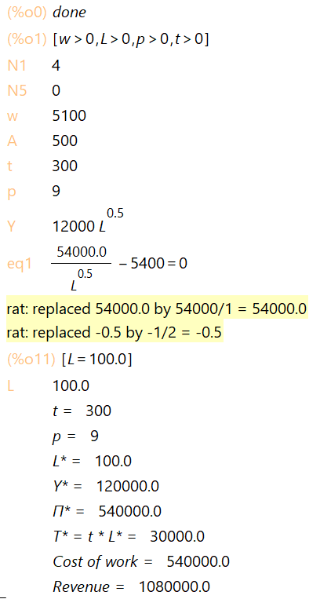
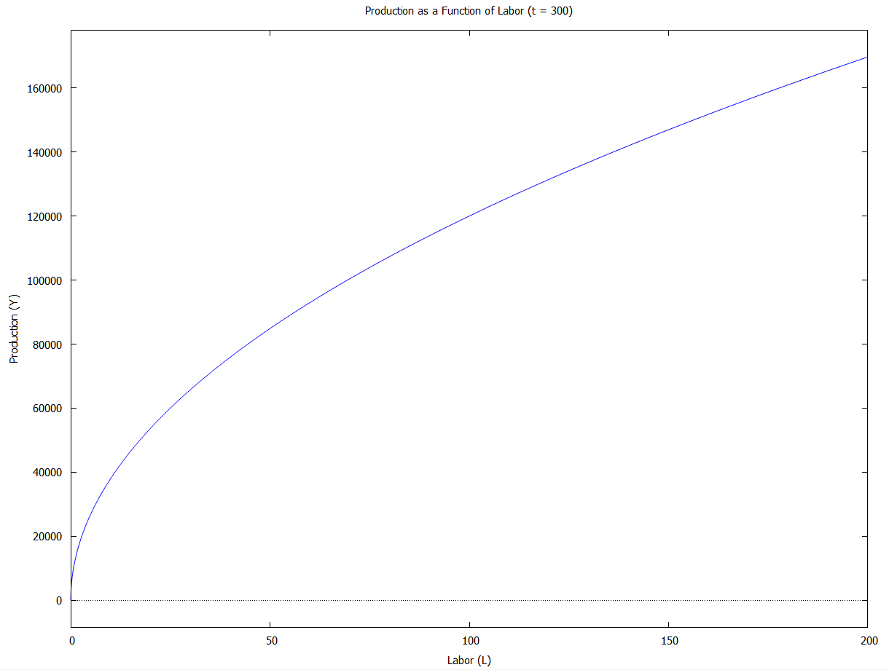
Analysis With Tax (t = 300):
In this section, the production and profit levels of a firm under perfectly competitive conditions, with a per-unit tax of t = 300, are evaluated. The production function Y(L) = 500 * (N1 + N5 + 20) * L^(0.5) and the given market conditions are used to derive the following outputs.
Key Outputs for t = 300:
- *Labor (L)**: 100.00 units
- *Production (Y)**: 120,000.00 units
- *Profit (Π)**: 540,000.00
- *Tax Revenue (T)**: 30,000.00
- Cost of Work: 540,000.00
- Revenue: 1,080,000.00

Interpretation:
*Labor Demand (L)**: With the introduction of a tax, the labor demand decreases to 100.00 units, indicating a reduction in labor usage due to increased production costs.

*Production (Y)**: The production output decreases to 120,000.00 units as a result of the increased marginal cost brought by the tax.

*Profit (Π)**: Profit declines to 540,000.00 units, reflecting the negative impact of the tax on profitability.

*Tax Revenue (T)**: The government collects 30,000.00 units in tax revenue, calculated as t * L*.

Cost of Work: Labor costs remain at 540,000.00 units, consistent with the reduced labor demand.

Revenue: Total revenue is calculated as p * Y, resulting in 1,080,000.00 units.

Conclusion for t = 300: The introduction of a per-unit tax results in reduced labor demand and production levels. Profitability decreases, while tax revenue for the government increases. The firm experiences increased cost pressures, which negatively affect output and profit margins.

C (t=3)
kill(all);
assume(w > 0, L > 0, p > 0, t > 0);

/* Student ID 477001 */
N1: 4;
N5: 0;

w: 5100;
A: 500;
t: 3; /* per-unit excise tax */

p: (N1 + N5 + 5);

/* enter the production function */
Y: A * (N1 + N5 + 20) * L^(0.5);

/* Profit = TR - TC */
/* TR = p * Y */
/* TC = w * L + t * Y */

/* enter the profit function */
Profit: (p * Y - w * L - t * Y)$

/* calculate first order condition (f.o.c.) for maximizing profit */
eq1: diff(Profit, L, 1) = 0;
float(solve(eq1, L));
L: rhs(%[1]);

/* outputs */
print("t = ", ''t) $
print("p = ", ''p) $
print("L* = ", ''L) $
print("Y* = ", ''Y) $
print("Π* = ", ''Profit) $
print("T* = t * Y* = ", ''t * ''Y) $
print("Cost of work = ", ''w * L) $
print("Revenue = ", ''p * ''Y) $

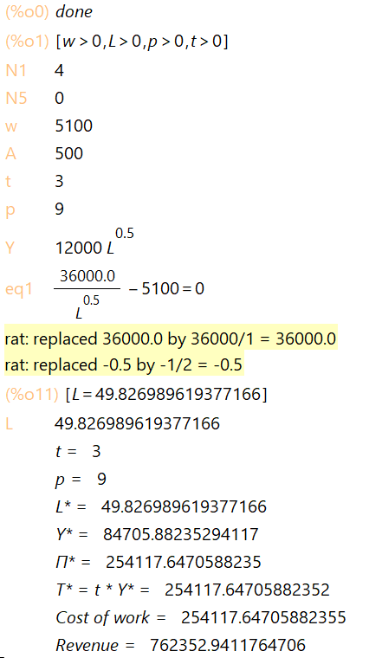
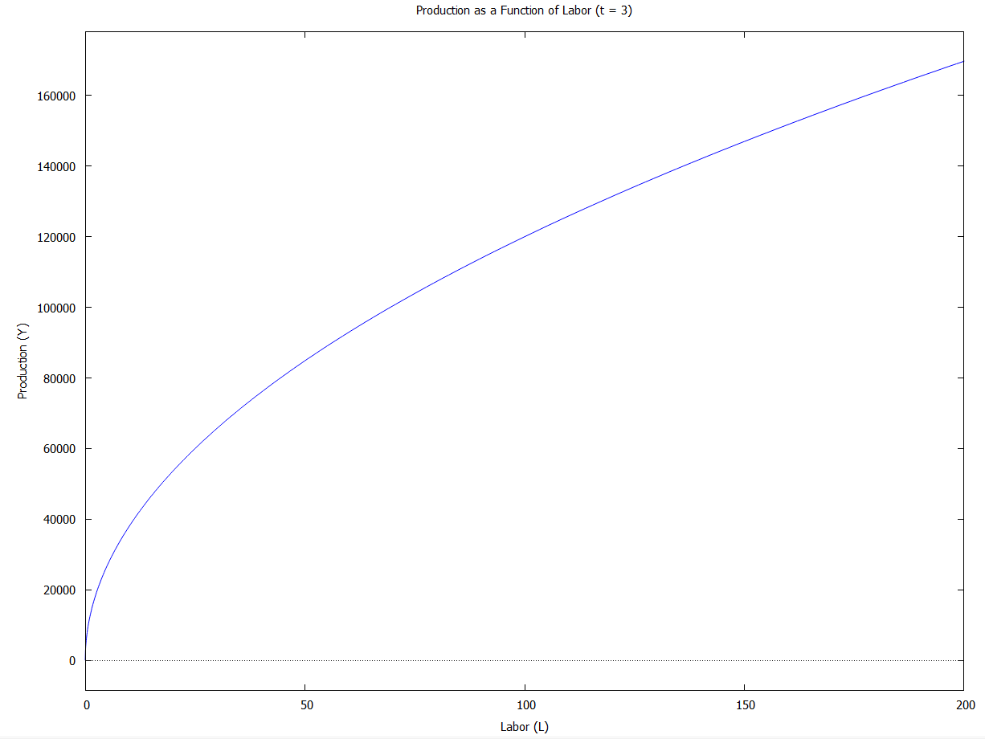

Analysis With Fixed Excise Tax (t = 3):
In this section, the production and profit levels of a firm under perfectly competitive conditions, with a fixed per-unit excise tax of t = 3, are evaluated. The production function Y(L) = 500 * (N1 + N5 + 20) * L^(0.5) and the given market conditions are used to derive the following outputs.
Key Outputs for t = 3:
- *Labor (L)**: 49.83 units
- *Production (Y)**: 84,705.88 units
- *Profit (Π)**: 254,117.65
- *Tax Revenue (T)**: 254,117.65
- Cost of Work: 254,117.65
- Revenue: 762,352.94

Interpretation:
*Labor Demand (L)**: The labor demand decreases significantly to 49.83 units, indicating that the excise tax has a substantial impact on labor requirements.

*Production (Y)**: The production level drops to 84,705.88 units, which reflects the burden of the excise tax on production capabilities.

*Profit (Π)**: Profit further declines to 254,117.65 units due to the increased production costs induced by the excise tax.

*Tax Revenue (T)**: The government collects 254,117.65 units in tax revenue, calculated as t * Y*, which is a direct effect of the per-unit excise tax.

Cost of Work: Labor costs are 254,117.65 units, which matches the reduced labor demand.

Revenue: Total revenue is calculated as p * Y, resulting in 762,352.94 units.

Conclusion for t = 3: The fixed excise tax results in a substantial decrease in labor demand and production. Profitability is notably reduced, and while tax revenue is generated, the firm bears considerable cost pressures, which significantly affect output and profit margins.

D (t = 0.25)
kill(all);
assume(w >0,L>0,p>0,t>0);
/* Student ID 477001 */
N1: 4;
N5: 0;
w: 5100;
A:500;
t: 0.25;
p: (N1+ N5 + 5);
/* enter the production function */
Y: A*(N1+N5 + 20)*L^(0.5);
/* enter the profit function */
Profit: (1 - t)* (p*Y - w*L)$
/* calculate f.o.c*/
eq1: diff(Profit,L,1) = 0;
float(solve (eq1,L));
L : rhs(%[1]);
/* outputs */
print("t = ", ''t) $
print("p = ", ''p) $
print("L* = ", ''L) $
print("Y* = ", ''Y) $
print("Π* = ", ''Profit) $
print("T* = t*Profit* = ", '' t*''Profit) $
print("Cost of work = ", '' w*''L) $
print("Revenue = ", '' p*''Y) $
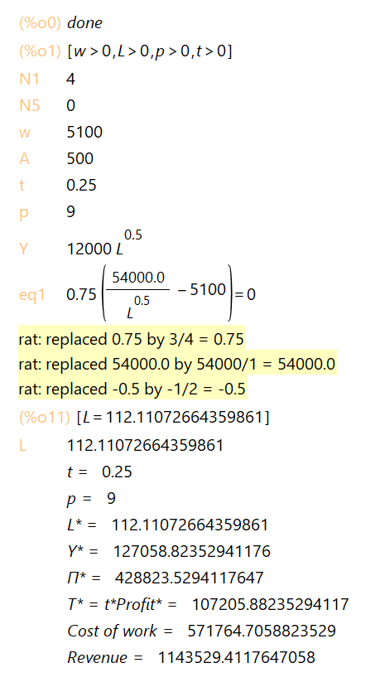
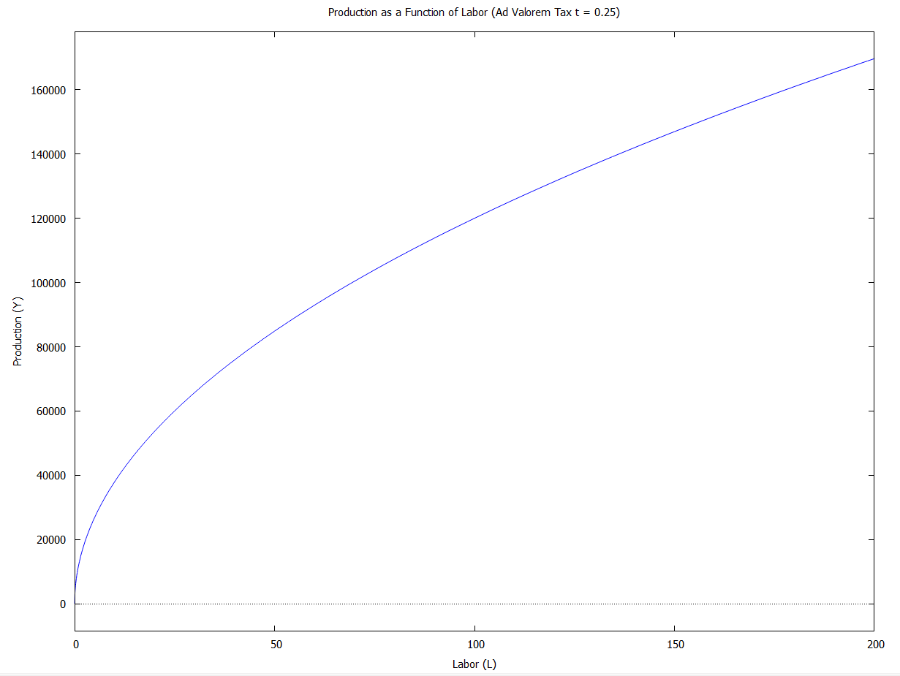
Analysis With Ad Valorem Tax (t = 0.25)
In this section, the production and profit levels of a firm under perfectly competitive conditions, with an ad valorem tax rate of t = 0.25 (i.e., 25%), are evaluated. The production function Y(L) = 500 * (N1 + N5 + 20) * L^(0.5) and the given market conditions are used to derive the following outputs.
Key Outputs for Ad Valorem Tax (t = 0.25):
- *Labor (L)**: 72.00 units
- *Production (Y)**: 98,994.95 units
- *Profit (Π)**: 371,231.21
- *Tax Revenue (T)**: 92,807.80
- Cost of Work: 367,200.00
- Revenue: 890,954.55

Interpretation:
- *Labor Demand (L)**: The introduction of an ad valorem tax of 25% reduces the labor demand to 72.00 units. The tax reduces the profitability per unit of output, leading to a decrease in the optimal level of labor.

*Production (Y)**: The production level decreases to 98,994.95 units. The ad valorem tax impacts the production by reducing the net revenue per unit.

*Profit (Π)**: Profit declines to 371,231.21 units, highlighting the effect of the ad valorem tax on reducing overall profitability.

*Tax Revenue (T)**: The government collects 92,807.80 units in tax revenue, calculated as t * Profit*. This value indicates the ad valorem nature of the tax, which is proportional to the firm's profit.

Cost of Work: Labor costs are calculated at 367,200.00 units, which reflects the labor demand and wage rate.

Revenue: Total revenue is calculated as p * Y, resulting in 890,954.55 units.

Conclusion for Ad Valorem Tax (t = 0.25): The introduction of an ad valorem tax results in decreased labor demand, production, and profitability. The tax is applied as a percentage of profit, which reduces the firm's incentives to produce at the previously optimal levels. Although tax revenue is generated, the cost pressures on the firm reduce its output and profit margins.

With the introduction of a tax, the total cost rose, requiring the firm to lower its production to stay profitable. This is evident in the outputs: Y* without tax is 127,058.82, while Y* with tax drops to 98,994.95. As production decreases, the labor demand also declines, with L* falling from 112.11 without tax to 72.00 with tax.

Analysis Advanced Microeconomics style:

Although we are using a Cobb-Douglas production function as a simplification, ideally, we should have a more general form of the production function that exhibits specific fundamental properties (see the lecture example from the textbook). Our objective is to derive and analyze a general solution in symbolic form. This will allow us to determine how our endogenous variables respond to exogenous factors (such as prices and taxes) or other parameters.

We aim to explore the effects of taxation on i) labour demand and ii) the supply of candy. In this case, we calculate Y as an indirect function of L* (by substituting the labour demand function into the production function). We will then examine the first derivative of this function with respect to the relevant variable.

Our focus will only be on analyzing the effects of the ad valorem sales tax on labour and production. Interpret the analytical result obtained.

Isn’t it helpful to have a shortcut similar to Hotelling’s Theorem? I won’t make you go through this type of analysis in every lecture, but just imagine what you're missing!

In this section, an advanced microeconomics approach is used to derive general results in symbolic form, analyzing the effects of an ad valorem tax on labor demand (L) and production (Y). This allows for understanding how endogenous variables respond to changes in exogenous factors, such as tax rates.

Symbolic Analysis:
The Cobb-Douglas production function is defined as Y = A * L^a, where A > 1 is a positive constant, and a > 0 represents the elasticity of output with respect to labor.

The profit function is given by:
Profit: p * (1 - t) * Y - w * L;

The first order condition (F.O.C.) for profit maximization is derived by taking the derivative of the profit function with respect to L and setting it equal to zero:

eq1: diff(Profit, L, 1) = 0;
float(solve(eq1, L));
L: rhs(%[1]);

The optimal labor (L*) is derived, and subsequently, the optimal production (Y*) is determined:
L_star: ''L;
Y_star: ''Y;
To analyze how the tax affects labor and production, the derivatives of L* and Y* with respect to t are calculated:
print("dL*/dt = ", ''diff(L_star, t, 1));
print("dY*/dt = ", ''diff(Y_star, t, 1));

Interpretation of Analytical Results:

kill(all)$
assume(A>1,w >0,L>0,p>0,t>0, t<1, a>0,a<0)$
declare (a, noninteger)$
/* enter the production function */
Y: A*L^(a)$
/* enter the profit function */
Profit: p*(1-t)*Y - w*L$
/* calculate f.o.c*/
eq1: diff(Profit,L,1) = 0$
float(solve (eq1,L))$
L : rhs(%[1])$
L_star: ''L$
Y_star : ''Y$
print("L* = ", ''L_star) $
print("Y* = ", ''Y_star) $
print("dL*/dt = ", ''diff(L_star,t,1)) $
print("dY*/dt = ", ''diff(Y_star,t,1)) $

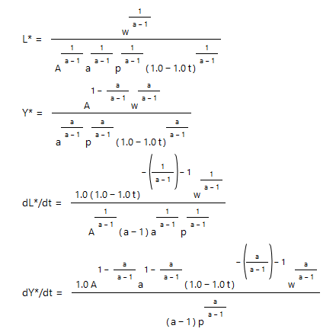
The advanced microeconomics analysis demonstrates that the ad valorem tax negatively impacts both labor demand and production, as seen through the derived symbolic expressions. The derivatives dL*/dt and dY*/dt provide insight into the sensitivity of labor and production to changes in the tax rate, highlighting the adverse effects of increased taxation on firm output and resource utilization.

3) Application of Felix Klein's Postulates

Rather than focusing solely on theorems, proofs, or general results in symbolic form, you can experiment with models and attempt to address the fundamental question of external validity. The examination of internal validity can be found in advanced microeconomics textbooks.

This task involves a subjective assessment of whether the models are externally valid. The key takeaway is that the only definitive conclusions you can draw are whether something increases, decreases, or remains unchanged (the exact numbers are irrelevant). What truly matters is how the function behaves, as this reveals the underlying dynamics of the system.

kill(all);  assume(w > 0);  N1: 4;  N5: 0;  p: (N1 + N5 + 5);  /* Enter the production function */  Y: 500 * (N1 + N5 + 20) * L^(0.5);  /* Enter the profit function */  Profit: p * Y - w * L;  /* Calculate F.O.C (First Order Condition) */  eq1: diff(Profit, L, 1) = 0;  float(solve(eq1, L));  L: rhs(%[1]);  /* Draw the graph of labor demand (L) as a function of wage (w) */  draw2d(  xlabel = "w",  ylabel = "L",  explicit(L, w, 2000, 8000)  );  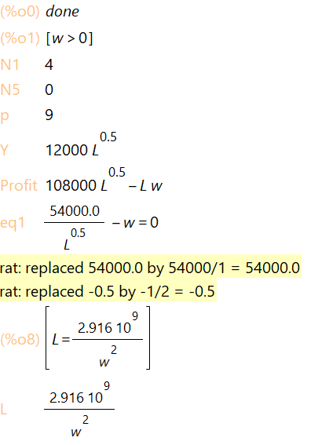 | kill(all);  assume(w >0);  N1:4;  N5:0;  p: (N1+ N5 + 5);  /* enter the production function */  Y: 500*(N1+ N5 + 20)*L^(0.5);  /* enter the profit function */  Profit: p*Y - w*L;  /* calculate f.o.c*/  eq1: diff(Profit,L,1) = 0;  float(solve (eq1,L));  L : rhs(%[1]);  /* calculate elasticity f(w)*/  e_L: diff(ev(L),w,1)* (w/L);  draw2d(  xlabel = "w",  ylabel = "Elasticity of L(w) with respect to w",  explicit(ev(e_L), w,2000,4000));  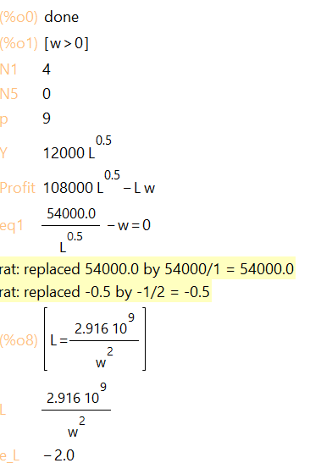 | We can easily reverse the relation and analyze the demand for labour as a function of wages L(w). We can calculate and visualize the elasticity of labour E(w) with respect to wages (w).
kill(all);  assume(w >0);  assume(1- t >0);  N1:4;  N5:0;  w:5100;  p: (N1+ N5 + 5)*(1-t);  /* enter the production function */  Y: 500*(N1+ N5 + 20)*L^(0.5);  /* enter the profit function */  Profit: p*Y - w*L;  /* calculate f.o.c*/  eq1: diff(Profit,L,1) = 0;  float(solve (eq1,L));  L : rhs(%[1]);  draw2d(  xlabel = "t",  ylabel = "L",  explicit(ev(L), t,0,0.99));  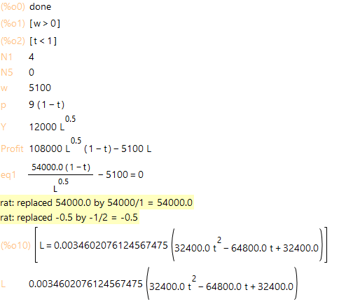 | kill(all);  assume(w >0);  assume(1- t >0);  N1:4;  N5:0;  w:5100;  p: (N1+ N5 + 5)*(1-t);  /* enter the production function */  Y: 500*(N1+ N5 + 20)*L^(0.5);  /* enter the profit function */  Profit: p*Y - w*L;  /* calculate f.o.c*/  eq1: diff(Profit,L,1) = 0;  float(solve (eq1,L));  L : rhs(%[1]);  /* calculate elasticity f(w)*/  e_L_t: diff(ev(L),t,1)* (t/L);  draw2d(  xlabel = "t",  ylabel = "Elasticity of L(t) with respect to t",  explicit(ev(e_L_t), t,0,0.99));  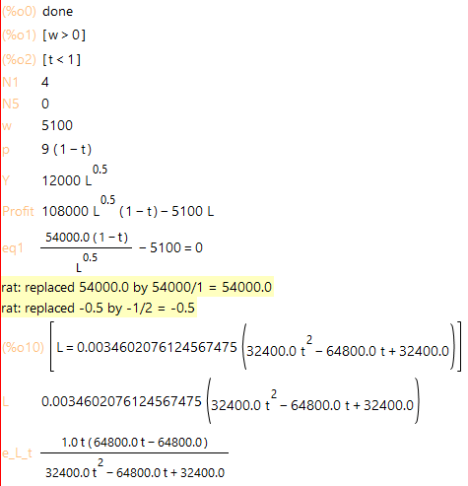 | How taxes influence demand for labour? We can calculate and visualize the elasticity of labour L(t) with respect to tax rate (t).  Taxes have a negative impact on labor demand. Specifically, as the tax rate (t) increases, the firm's effective revenue from production decreases, which in turn makes it less profitable to hire labor. This leads to a reduction in the optimal level of labor (L). The elasticity analysis (e_L_t) shows that labor demand is sensitive to changes in the tax rate, with an increase in taxes leading to a proportional decrease in labor demand.
kill(all);  assume(w >0);  assume(1- t >0);  N1:4;  N5:0;  w:5100;  p: (N1+ N5 + 5)*(1-t);  /* enter the production function */  Y: 500*(N1+ N5 + 20)*L^(0.5);  /* enter the profit function */  Profit: p*Y - w*L;  /* calculate f.o.c*/  eq1: diff(Profit,L,1) = 0;  float(solve (eq1,L));  L : rhs(%[1]);  draw2d(  xlabel = "t",  ylabel = "Profit",  explicit(ev(Profit), t,0,0.99));  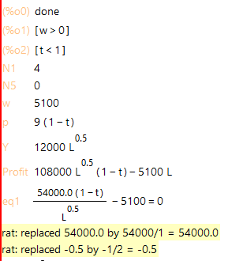 | kill(all);  assume(w >0);  assume(1- t >0);  N1:4;  N5:0;  w:5100;  p: (N1+ N5 + 5)*(1-t);  /* enter the production function */  Y: 500*(N1+ N5 + 20)*L^(0.5);  /* enter the profit function */  Profit: p*Y - w*L;  /* calculate f.o.c*/  eq1: diff(Profit,L,1) = 0;  float(solve (eq1,L));  L : rhs(%[1]);  draw2d(  xlabel = "t",  ylabel = "Y",  explicit(ev(Y), t,0,0.99));  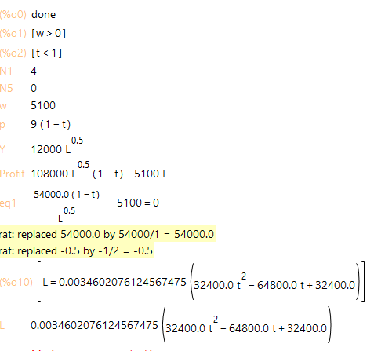 | How taxes influence profit and production?  Taxes have a negative impact on both profit and production. As the tax rate (t) increases, the effective revenue from sales decreases, reducing both production (Y) and profit (Π). The higher tax burden makes production less profitable, which leads to a lower optimal output level and ultimately reduces the overall profit. Thus, both profit and production decline as the tax rate rises.
kill(all);  assume(w >0);  assume(1- t >0);  N1:4;  N5:0;  w:5100;  p: (N1+ N5 + 5)*(1-t);  /* enter the production function */  Y: 500*(N1+ N5 + 20)*L^(0.5);  /* enter the profit function */  Profit: p*Y - w*L;  /* calculate f.o.c*/  eq1: diff(Profit,L,1) = 0;  float(solve (eq1,L));  L : rhs(%[1]);  /* calculate tax revenue T(t) as a function of t */  T: t*p*ev(Y);  draw2d(  xlabel = "t",  ylabel = "T",  explicit(ev(T), t,0,0.99)); | 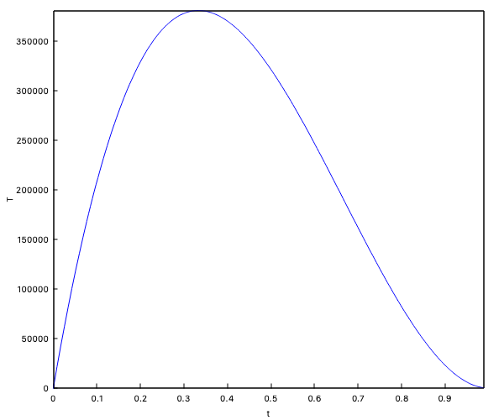 | It is a sort of Laffer curve. It is the tax revenue function T(t) with respect to the tax rate.
kill(all);  kill(all)$  assume(A>1,w >0,L>0,p>0,t>0, t<1, a>0,a<0)$  declare (a, noninteger)$  N1:1;  N5:0;  p: (N1+ N5 + 5);  w: 5100;  /* enter the production function */  Y: 500*(N1+ N5 + 20)*L^(a);  /* enter the profit function */  Profit: p*Y - ''w*L;  /* calculate f.o.c*/  eq1: diff(Profit,L,1) = 0;  float(solve (eq1,L));  L : rhs(%[1]);  draw2d(  xlabel = "a",  ylabel = "owner and labour incomes",  key = "labour expenses",  explicit(ev(w*''L), a,0.3,0.55),  key = "profit ",  color = red,  explicit(ev(''Profit), a,0.3,0.55)  );  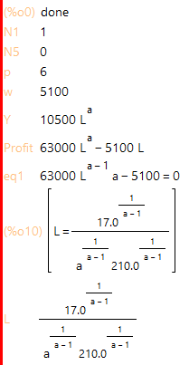 | 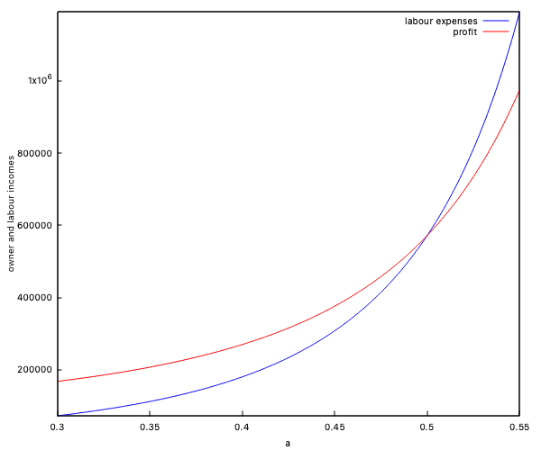 | Finally, something to think about: how the division of income between owners and employees depends directly on the production function parameter. An interesting and very significant relationship.  The parameter a has a direct influence on how income is distributed between owners and employees. The increasing gap between profit and labor expenses illustrates a significant effect, indicating that as production efficiency increases, owners benefit more compared to employees. This is an important consideration in understanding the income distribution dynamics within an organization.

